|  |  |  |  |  |  |
| --- | --- | --- | --- | --- | --- |
| Name | KEY | Date |  | Teacher |  |

## Assessment type: Task 12 Sci Inq 4 Part 2 Total 25M

### Task: Matching profiles – DNA sequencing (fingerprinting)

You will examine a technique used to identify the original source (carcase) of a contaminated meat sample.

At the end of this document you will find:

* four meat samples (DNA sequences)
* one restriction enzyme template.

### Recombinant DNA technology: Matching profiles

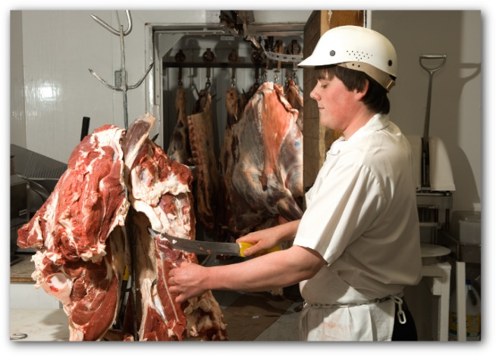Use the information given and your own research from other resources, such as the internet and textbooks to examine a technique used to identify the original source (carcase) of a contaminated meat sample.

A butcher has been told that some of the meat in his shop has been contaminated with the pesticide DDT. He needs to track down the source and inform his supplier that the meat is not suitable for human consumption. Recombinant DNA technology can be used to identify the original source. You are the scientist who has been given the task to identify the source.

During extensive investigations the origin of the contaminated meat sample was narrowed down to three carcases. Meat samples were taken from the three carcases and carefully labelled as meat sample 1, 2 and 3. The source of the contaminated meat sample can be found by separating and comparing DNA fragments of the affected meat sample with DNA fragments from the three meat samples. A restriction enzyme used to cut DNA into fragments is EcoRI.

### 

### What you need to do

1. Cut out the three meat samples and the contaminated meat sample DNA sequence from the samples provided. Glue together to form a single line for each sample.
2. Use your activated restriction enzyme to locate the restriction site(s) for the contaminated meat sample.
3. For each sample you will need to cut it at the beginning and the end using both parts of your restrictive enzyme. This will produce fragments.
4. For each sample, group identical fragments together.
5. Arrange the groups of fragments into a column from longest to shortest for each sample.
6. Compare each sample’s DNA fingerprint with the contaminated meat sample. To do this you need to compare the length and sequence in each group of fragments with the contaminated sample.
7. Answer the questions below.

### **Questions**

1. Draw a DNA fingerprint for the meat samples, including the contaminated sample; on the ‘gel’ below (remember DNA molecules are negative). (4M)

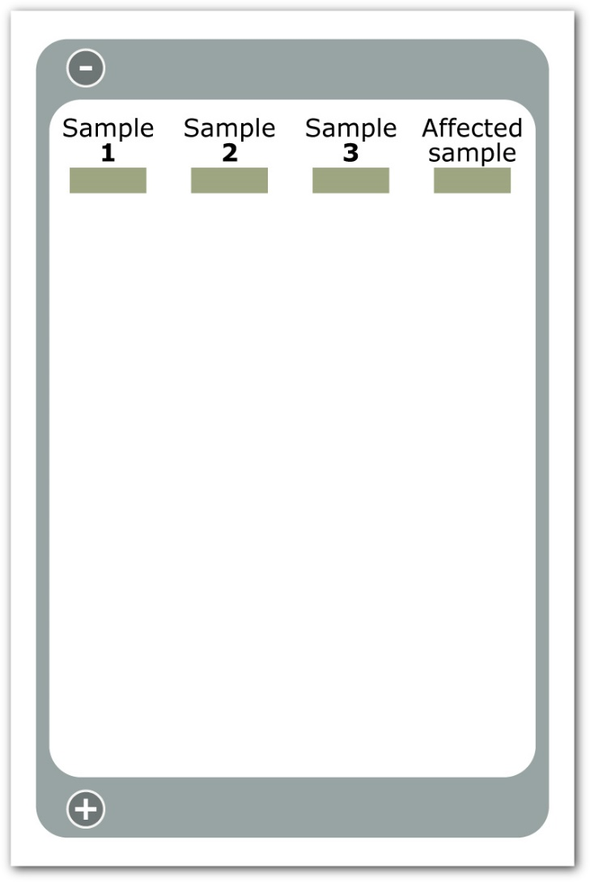

1. What conclusions can you make from comparing the DNA fragments in the above activity?

|  |
| --- |
| Meat Sample 2 was the same as the contaminated sample.  Any other reasonable conclusion based on information above.  2 marks |

1. Could the restriction enzyme, EcoRI, be used to cut DNA from another species? Explain your answer.

|  |
| --- |
| Yes – DNA is the same structure in all species so if the recognition site is found on another species DNA then it will cut the DNA at that recognition site.  2 marks |

1. Restriction enzymes are used to cut DNA into fragments. The restriction enzyme Alu1 produces blunt ends while EcoRI produces sticky ends. Explain what is meant by ‘blunt ends’ and ‘sticky ends’.

|  |
| --- |
| Blunt ends – straight cut across the DNA leaving no unmatched nucleotides  Sticky ends – cut leaving unmatched bases at each end  2 marks |

1. If you wished to join pieces of DNA fragments, which type of enzyme would you use?

|  |
| --- |
| DNA ligase (ligase enzyme)  1 mark |

1. Using the enzyme identified in the previous question would you expect a sample containing DNA fragments with sticky ends to join together faster than a separate sample containing DNA fragments with blunt ends? Explain your choice. Assume all other variables are kept constant.

|  |
| --- |
| Yes you would.  Unmatched bases from the restriction enzyme cut attract corresponding bases which match the overhanging sequence specifically which allows for a faster join.  Blunt ends are nonspecific as there are no recognition sites for them to bind to.  2 marks |

## Multiple copies of one long fragment of DNA where made using PCR. The copies were treated with the restriction enzyme EcoRI. A DNA profile was made using gel electrophoresis and three shorter fragments were produced as shown below.

The size of each fragment is given in kbp (kilo base pairs).

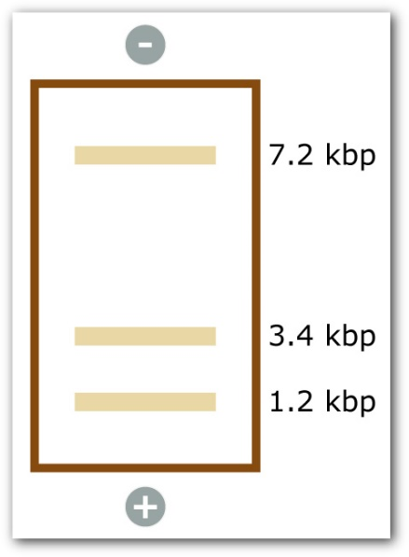

a) In which direction did the fragments travel?

|  |
| --- |
| Negative to Positive 1 mark |

b) What size was the original fragment of DNA before being treated with EcoRI?

|  |
| --- |
| 11.8kbp 1 mark |

c) How many recognition sites for the restriction enzyme EcoRI were present in the original fragment of DNA?

|  |
| --- |
| 2 1 mark |

d) A copy of the original fragment of DNA was treated with another restriction enzyme, Alu1. A DNA profile was produced using gel electrophoresis and only one DNA fragment was produced. Explain.

|  |
| --- |
| Alu 1 found no recognition sites on the DNA strand  Therefore no separate strands would be seen on the gel as there is still only one piece of DNA.  2 marks |

8. a) Plasmids are used as vectors in the production of recombinant DNA to produce transgenic organisms.

Briefly explain the following terms: (4M)

* + 1. transgenic organism

|  |
| --- |
| An organism which has an altered phenotype as a result of its genetic modification |

* + 1. plasmid

|  |
| --- |
| A small ring of DNA found in bacteria which is not essential to the bacteria. Often used as a vector to transfer genes from one organism to another. |

* + 1. vector

|  |
| --- |
| An intermediate host which carries a gene from one organism to another. |

* + 1. recombinant DNA.

|  |
| --- |
| A DNA fragment which is integrated into a DNA molecule to which it does not normally belong. |

b) Summarise the steps, including the enzymes involved, in the production of recombinant DNA.

|  |
| --- |
| Two pieces of DNA are cut using the same restriction enzyme. Usually to produce matching sticky ends. (can use a plasmid as an example)  DNA pieces are put together and matching sticky ends come together (according to base paring). This is called annealing  Fragment joined together by DNA ligase producing a molecule of recombinant DNA. (3M) |